Spoke 2: SEA BIODIVERSITY

Vision

The vision of Spoke 2 is a marine biodiversity preserved from unsustainable use of its resources and from anthropogenic impacts, scientifically based managed and, wherever necessary restored to assure ecosystem functions and services provision.

Mission

The mission of Spoke 2 is to provide solutions to reverse marine biodiversity loss and manage marine resources sustainably

Strategic Objectives

Definizione degli obiettivi chiave di ricerca e innovazione dello spoke (5-10 righe massimo)
- Assessment and mitigation of impacts and threats to marine biodiversity
- Restoration of biodiversity and marine ecosystems
- Promotion of a sustainable valorization of marine resources (fishery and aquaculture)
- Development of a biodiversity-oriented planning of the human uses of the sea
- Development of innovative multi-omics based technologies to address emergent biodiversity threats.

Diagramma di gantt 36 mesi

Suddivisione temporale

State-of-art Analysis
General
Marine biodiversity is essential for the health of seas and oceans, which is ultimately key to human well-being and the survival of the whole planet. Healthy seas are critical for achieving a sustainable development of our society, and undoubtedly many of the Sustainable Development Goals (SDGs) may not be realized without achieving SDG14 for a healthy ocean. Spoke 2 aims at implementing concrete actions to reduce human pressure on Mediterranean marine biodiversity by defining and testing solutions to reduce the biodiversity loss due to human activities such as fishery, aquaculture and emerging pollutants, also through development of early warning systems based on omics and implementation of restoration actions.

Mapping gaps and opportunities
Per punti 5-10 righe
- More sustainable fishery and aquaculture approaches will be developed to reduce threats and impacts on marine ecosystems and biodiversity by developing new KETs, methodologies and strategies, as well as tuning more eco-sustainable blue biotechnologies to support the sustainable valorization of marine biomass under a circular, interdisciplinary approach.
- Development of methodologies and implementation of restoration actions in critical marine habitats from the intertidal to the deep sea. A strategy for a safer marine habitat restoration and biodiversity-oriented planning of the human uses of the sea will be implemented.
- Innovative technologies for marine biodiversity to observe, restore and to address emergent biodiversity threats will be developed, benefiting from the latest multi-omics technologies, the use of big data, the implementation of bioarchives and digital tools.

Research & Innovation priorities
Descrizione delle principali linee tematiche di ricerca divisi in WP e task. Massimo 1 pagina. Meglio se per punti

WP1 - Assessment and prioritization of the main anthropogenic drivers, including emerging challenges that undermine marine biodiversity and services. Elucidating interactions through a multiple-stressors approach, will support the development of innovative solutions to counteract marine biodiversity loss, promoting the health of marine ecosystems for future generations.
WP1.1 – The activity 1.1 aims at developing strategies to move toward a more sustainable fishery. The specific goals of the activity are:
- Reduction of fishing impacts and protection of biodiversity.
- Managing geographical expansion of invasive Non-Indigenous Species to increase the resilience of ecological and socio-economic systems.
- Use of big data to prevent illegal fishing and support marine biodiversity.
- Identify potential impacts of Marine Recreational Fisheries (MRF) on biodiversity and develop practical, technical and technological solutions to mitigate these impacts.
- Investigate biodiversity and ecosystem services, highlighting risks from human pressures and climate change, identifying conservation priorities and aligning ecosystem services with Blue Growth goals.
- Develop an integrated observing and modelling approach for pelagic nektonic biodiversity, ecosystem functions and services.

- 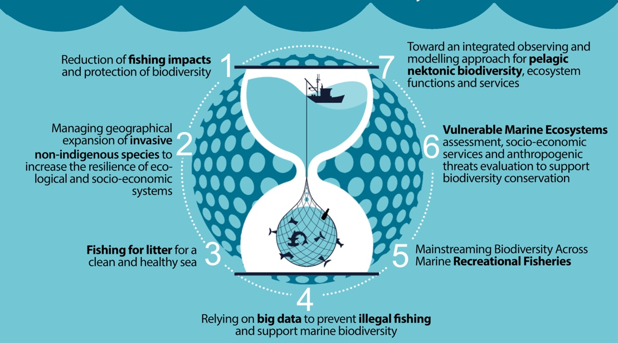

WP1.2 – Zero Pollution Strategy for Biodiversity Protection. The WP aims to
- map the occurrence and distribution of Emerging Contaminants (EC) in the Mediterranean Sea;
- identify priority contaminants through laboratory- and field-based studies using on a wide panel of diagnostic tools at different level of biological organization;
- develop innovative effect-based biosensors for EC monitoring;
- evaluate the actual risk of biodiversity loss due to EC in Mediterranean field conditions;
- generate knowledge for environmental normative implementation, biodiversity protection, socio-economic and industrial innovation, in line with recent EU Zero Pollution Action Plan and the Horizon Missions;
- innovation and technology transfer toward plastic pollution reduction and valorization.

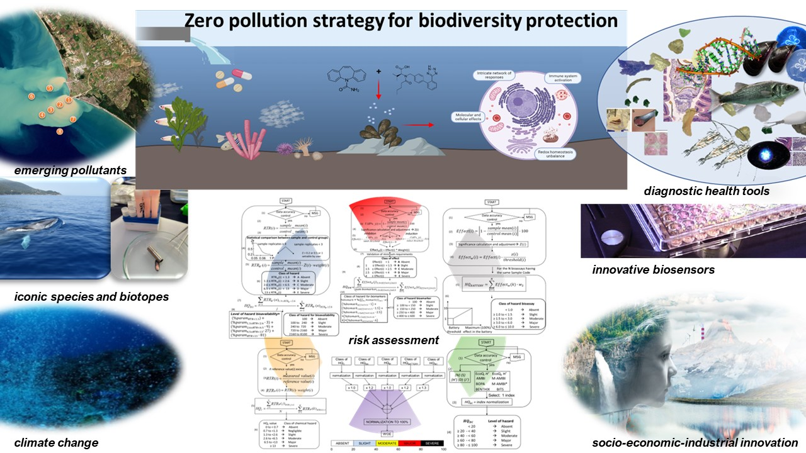

WP2 – Marine Ecosystem Restoration (MARES). The WP aims to provide a key contribution towards restoration of degraded marine ecosystems, support biodiversity resilience through habitat restoration, implementing to an unprecedented spatial scale the restoration of marine habitats and providing a step change in the marine restoration strategy at Italian level through new methodologies, maps and success measures.
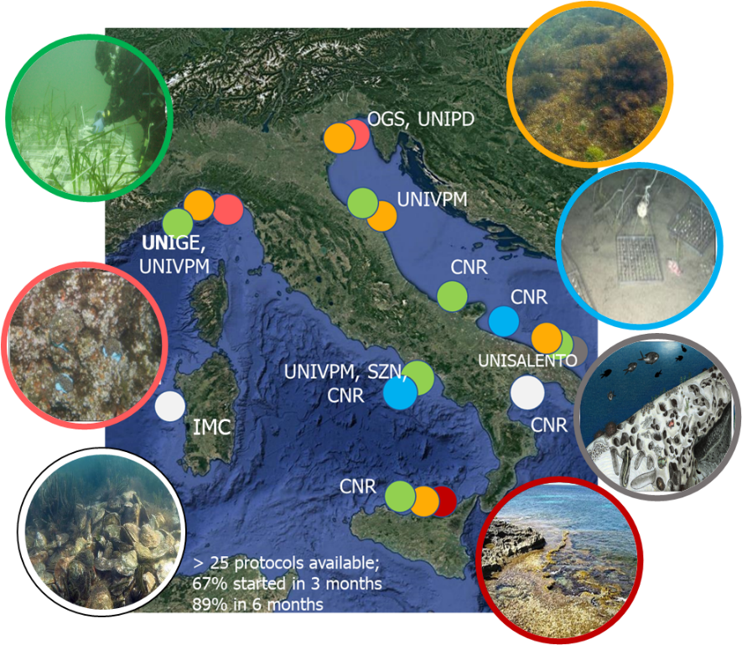
seagrass
macroalgal forest
coralligenous
barren grounds
vermetid reef
oyster reef
deep sea

WP3 – Sustainable aquaculture. The WP aims to the diversification and growth of aquaculture as part of an integrated strategy of marine bioeconomy, the reduction of the impact of aquaculture on the marine ecosystem biodiversity through the development of sustainable technologies, tools and strategies.

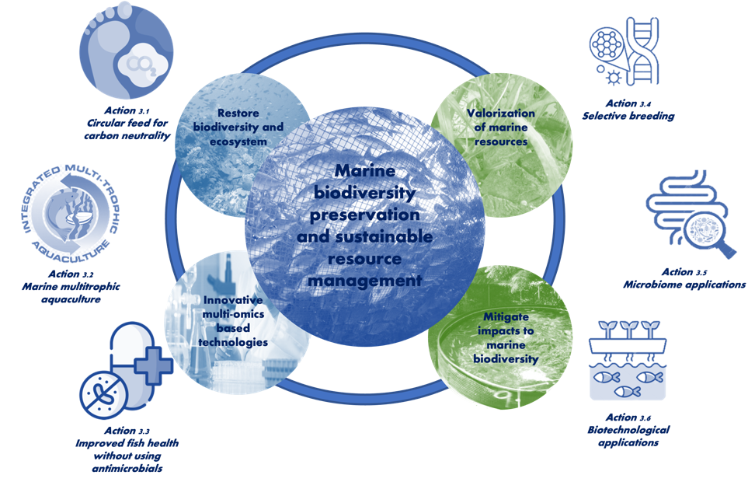

WP4 – Marine Spatial Planning for Biodiversity (MSP4Biodiversity). The WP aims to address and develop the theme of MSP of Italian marine waters in a wider Mediterranean context, guaranteeing and strengthening the protection of the biodiversity of marine ecosystems and the sustainability of the uses of the sea, through the application of social-ecological and transdisciplinary approaches, integrating marine/maritime sciences, spatial planning, social and economic sciences
A stable infrastructure of knowledge and related services on the subject of MSP, biodiversity and sustainable blue economy (e.g. "Transdisciplinary Virtual Center for Maritime Space Planning and Sustainable Blue Economy") will be established.

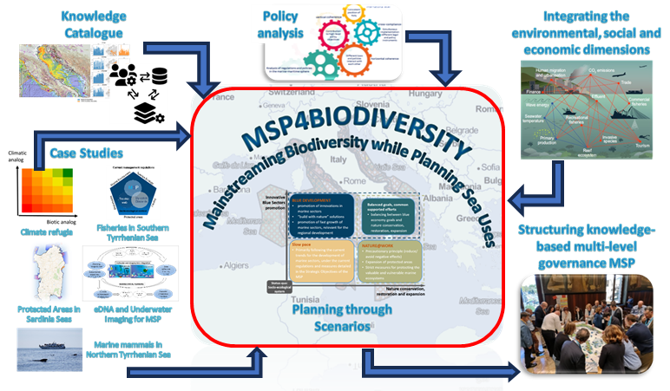
WP5 - Multi-omics based technologies to study biodiversity and address biodiversity threats.
The WP implements cutting-edge technologies for the collection of marine omics data, their analysis, and interpretation to enable scalable, fast, and cost-effective (SFC) response actions to emerging biodiversity threats. A major effort of WP5 is the development and establishment of an Italian Omics Observatory Network for Marine Biodiversity. The observatory will be implemented at four marine LTER stations in Italian seas, namely the Area Marina Protetta di Portofino (Ligurian Sea), Transetto Senigallia-Susak (Central Adriatic Sea), Golfo di Trieste (Northern Adriatic Sea), and Marechiara-Golfo di Napoli (Tyrrhenian Sea). At each station, up-to-date protocols will be developed to conduct size-fractionated filtrations of large seawater volumes and metagenomic/metabarcoding analyses of seawater samples on a regular basis in accordance with international standards and aligned with international and European initiatives for global ocean observation, such as the European Marine Omics Biodiversity Observation Network (EMO BON).
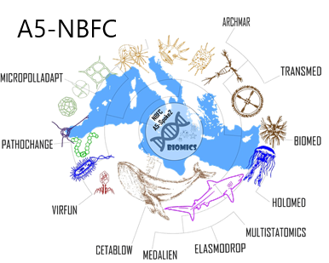

Expected Impacts

Scientific Impact
Poche righe
Spoke 2 significantly advances the development and application of measures to reduce direct human impact on marine biodiversity, through a multidisciplinary approach from omic investigations to maritime spatial planning.
Expected scientific impacts are expected in terms of better understanding fishery related impacts, in developing biodiversity friendly aquaculture approaches, in establishing best practices for restoration implementation and monitoring, in developing genomic pipelines and biodiversity monitoring tools based on omic approaches and in establishing a toolbox for biodiversity oriented maritime spatial planning.
The research will provide novel insights on the actual risks for Mediterranean biodiversity due to the presence of emerging contaminants. A wide panel of such chemicals will be prioritized in terms of presence and distribution in waters, sediments and biota, as well as toxicological effects on key sentinel species. Diagnostic tools will be harmonized at different levels of biological organization, from genes to communities, and integrative approaches developed for various typologies of stakeholders. Innovative effect-based biosensors for emerging contaminants and technologies toward plastic pollution valorization will be developed.

Economic Impact
Es Crescita, competitività e creazione di posti di lavoro. Poche righe
- Blue Jobs. All the activities in the Spoke will produce knowledge and high-profile skills for young generations that can be functional to cover positions in the ‘blue jobs’ system, through development of new jobs (e.g. marine restoration practitioners) or in the transformation of existent practices in a sustainable conversion (e.g. fishery and aquaculture).
- Tourism and Recreation. Sustainably performed exploitation activities will have a potential appeal on tourism and recreation (such as fishing tourism, visit to aquaculture plants, SCUBA diving). Protected and restored marine areas will have a strong potential to increase sustainable and educational tourism.
- Nutraceutics, Cosmetics. Bioactive molecules from macroalgae, marine biomasses from bycatch and, in general, from marine animals will be explored or managed for applications in nutraceutical, feed and cosmetics production (see Spoke 6).
- Reduced Healthcare Costs. The health benefits of marine systems translate to lower medical expenses, as residents experience fewer pollution-related and stress-induced illnesses (see Spoke 6).
- New business models and socio-economic-industrial vision will be provided to sustain biodiversity protection and economic prosperity transforming production and consumption modes, rethinking the way goods and services are designed, produced, and disposed, directing investments towards zero pollution. Industrial innovation and technology transfer will support marine litter valorization and waste-to-energy processes.
Social Impact.
Miglioramento della qualità della vita, equità e inclusione. Poche righe
- Enhanced Aesthetic and Recreational Value. Preserved, restored and more sustainably managed coastal areas will provide spaces for leisure, which can enhance residents' and visitors’ quality of life.
- Educational Opportunities. Protected and sustainably managed marine coastal areas serve as tools for environmental education, teaching residents and tourists about biodiversity and sustainability.
- Public awareness. Citizen engagement will raise public awareness on the importance of monitoring, preserving and restoring biodiversity.
- Increased citizens awareness on emerging contaminants threats. Scientifically-sound basis for responsible and sustainable choices (e.g. pharmaceuticals and personal care products). Human health risks from the consumption of seafood contaminated with emerging contaminants.

Environmental Impact.
Contributi a sostenibilità e resilienza. Poche righe
- Water Quality Monitoring and Health Status Assessment. Through the monitoring of emerging pollutants, a mapping of sources and risks will be provided also in a climate change scenario. Tools will be developed to monitor water wuality and health status of marine organisms.
- Biodiversity Support. Reduction of fishery (commercial, recreational, illegal) impact on marine biodiversity; reduction of aquaculture related impacts on wild species and environment; maritime spatial planning biodiversity oriented.
- Biodiversity & Ecosystem Functioning. Through the implementation of restoration actions, based on single or multiple species restocking and through settlement facilitation, biodiversity related functions and services will be preserved or re-established.
- Reduction of living resources exploitation. Through several approached, among which the development of circular feeds and marine biomolecules applications from use of bycatch.
- Climate Regulation. Maintenance of healthy marine ecosystems, in particular those characterized by photosynthetic and calcifying organisms will contribute to climate regulation by uptake and storage of CO₂.
- Normatives implementation. Update of environmental normative and guidelines to include emerging contaminants, defining thresholds for biodiversity protection.

Stakeholder Engagement

Through interactions with the relevant Ministries, local administration, EU working groups and relevant scientific societies, researchers of Spoke 2 will be able to inform politics on best practices and provide tools for decision makers, in order to comply with EU and UN directives. Specifically in the field of ecological restoration and maritime spatial planning, new relevant commitments for Italy refer to the Nature Restoration Regulation entered into force in August 2024 and the Maritime Spatial Planning Directive, entered into force in 2014, but strongly delayed in its application in Italy.
Public-private sectors interactions and partnerships will be envisaged and implemented, in order to enhance the implementation scale of interventions in the different sectors (e.g., in the field of ecological restoration, fishery and aquaculture) and to upscale the technology readiness level of prototypes, e.g. sampling tools, health-tools, biomolecules applications.

